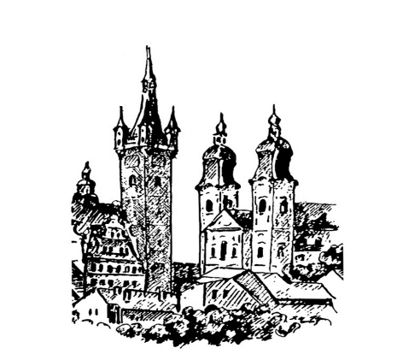***Šachklub Sokol Klatovy***

***holds***

***31th annual chess tournament***

## OPEN Klatovy 2025

* 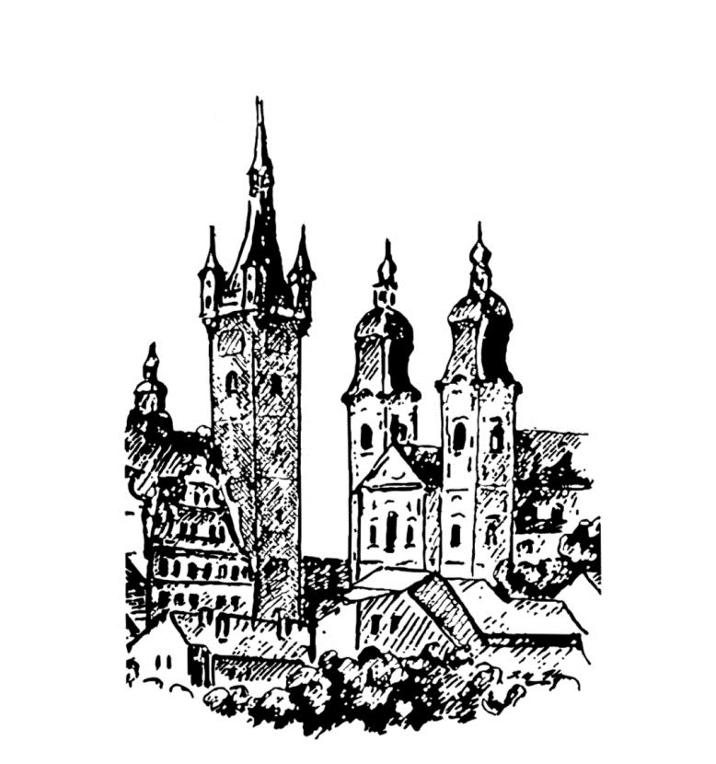***FIDE OPEN A (ELO* > *1800)***
* ***FIDE OPEN B (ELO* <*2000)***
* ***FIDE OPEN C (Seniors 50+)   
  this tournament is played as a memorial to Ing. Jaromír Novák***

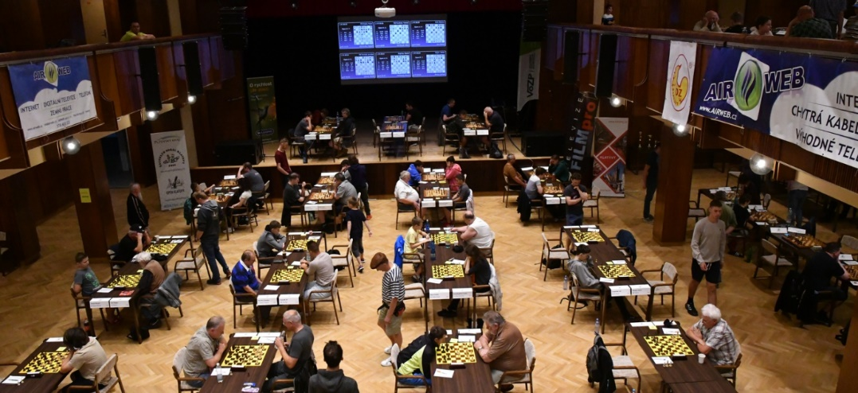

***Klatovy, June 28th – July 6th 2025***

[**www.openklatovy.cz**](http://www.openklatovy.cz/)





**Venue:** The Culture House Klatovy, Domažlická 767

**Registration:** On June 27th from 5 p.m. to 9 p.m., on June 28th from 10 a.m. to 3 p.m.

**System of play:** Swiss open tournament, 9 rounds, 2 x 2 h + 30 s per move

**Accommodation:** See below

**Catering:** The refreshment corner will be opened throughout the venue. The meals will be provided at the venue. It is possible to order **lunches** and **dinners** in advance. The menu will be published on the tournament website.

**Applications:** To be sent by **June 8th 2025** to the address of the tournament director.

**Director:** Ing. Pavel Hrdlica,[sachklub.klatovy@seznam.cz](mailto:sachklub.klatovy@seznam.cz)

**Organizer:** Ing. Karel Nováček, [novacek.chess@seznam.cz](mailto:novacek.chess@seznam.cz), phone: +420 737 337 955

**Time schedule:** 1st round: June 28 at 4 p.m. 4th round: July 1 at 4 p.m. **7th round: July 4 at 2 p.m.**  
2nd round: June 29 at 4 p.m. 5th round: July 2 at 4 p.m. 8th round: July 5 at 4 p.m.  
3rd round: June 30 at 4 p.m. 6th round: July 3 at 4 p.m. 9th round: July 6 at 9 a.m.

**Financial prizes:** **Tournament A Tournament B Tournament C**

1st place: 15,000 CZK 4,000 CZK 4,000 CZK

2nd place: 10,000 CZK 3,000 CZK 3,000 CZK

3rd place: 7,000 CZK 2,000 CZK 2,000 CZK

4th place: 5,000 CZK 1,700 CZK 1,700 CZK

5th place: 4,000 CZK 1,500 CZK 1,500 CZK

6th place: 3,000 CZK 1,300 CZK 1,300 CZK

7th place: 2,400 CZK 1,200 CZK 1,200 CZK

8th place: 1,800 CZK 1,100 CZK 1,100 CZK

9th place: 1,600 CZK 1,000 CZK 1,000 CZK

10th place: 1,400 CZK 900 CZK 900 CZK

11th place: 1,200 CZK 800 CZK 800 CZK

12th place: 1,000 CZK 700 CZK 700 CZK

1st woman: 1,000 CZK 700 CZK 700 CZK

2nd woman: 700 CZK 500 CZK 500 CZK

3rd woman: 500 CZK 300 CZK 300 CZK

**Team competition prizers:** 4-player team tournament wins 2 000,- CZK at tournament A 4-player team tournament wins 1 000,- CZK at tournament B

(counting the 4 best from the same chess club)

**Material prizes:** The best boys and girls in categories U8, U10, U12, U14, U16 in both categories will be given material prizes. The youngest and the oldest participant will receive a material prize as well.

**Entry fee: Tournament A Tournament B Tournament C (50+)**

(ELO FIDE) (ELO FIDE or CR) (no ELO restrictions)

2300 and more 0 € 0-2000 : 32 € born 1975 and older: 32 € 2200 – 2299 28 €

2000 – 2199 36 €

1800 – 1999 44 €

The organizer is allowed to except players with ELO lower then 1 800 into the A Tournament. The entry fee shall be increased by 20 € in such a case.

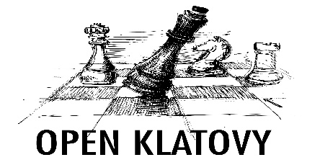**Discounts on entry fee** (more discounts can be applied at once)**:**

A. Youth under 16 (born in 2009 and later) – 4 € discount.

B. Women - 4 € discount.

C. Last year’s participants – 4 € discount.

D. Holders of ZTP card (disabled people) and seniors (born in 1960 and earlier) – 4 € discount.

**Accompanying program:**

The sites for the competitions will be posted at the information centre.

**• Active chess tournament: (Sunday June 29th at 9:00)**

Swiss tournament 7 rounds, 2x15 min., financial prize (1 000 CZK) and material prizes, entry fee 100 CZK

**• Active chess seniors tournament: (Sunday June 29th at 9:00)**

Swiss tournament 7 rounds, 2x15 min., for players born in 1960 and earlier, financial prize (1 000 CZK) and material prizes, entry fee 100 CZK

**• Active chess juniors tournament: (Sunday June 29th at 9:00)**

Swiss tournament 7 rounds, 2x15 min., for players born in 2010 and later, category boys born in 2011 and later, category girls born in 2011 and later, material prizes for everyone, entry fee 100 CZK

**• Table tennis tournament: (Monday June 30th at 9:00)**

System based on the number of participants, material prizes, starting fee 50 CZK

**• Beach volleyball tournament: (Tuesday July 1st at 9:00)**

Depending on weather conditions. System based on the number of participants. Material prizes, entry fee 300 CZK /team

**• Football tournament: (Wednesday July 2rd at 9:00)**

System based on the number of participants, material prizes, entry fee 300 CZK/team.

**• Blitz tournament: (Friday July 4th at 20:00)**

Swiss tournament 15 rounds, 2 x 3 min.+ 2 s, financial prize (1 000 CZK), material prizes, entry fee 100 CZK

**• Tour of town Klatovy**

Guided tour of the historical part of the town. Date to be announced.

**Additional information:**

Filled-in applications (form is available on tournament website) should be sent via e-mail: sachklub.klatovy@seznam.cz. You can verify your acceptance to the tournament by contacting the tournament director. In the application form state your FIDE ID number, your address, phone number and e-mail. Accepted players who properly cancel their application will get their money for accommodation and starting fee. The cancellation fee is free 14 days before tournament, 200 CZK 7-13 days before the tournament and 300 CZK 1-6 days before the tournament.

The starting fee and accommodation prices should be sent by a bank transfer to the account of tournament’s director: **IBAN CZ50 2010 0000 0021 0250 1446**. It is possible to send money for more players in one transfer (state the details in the message for recipient or in the e-mail). An additional cost of 100 CZK will be added to payments done only at registration.

Accommodation requirements will be dealt with in the order of application arrival for players who already paid starting fee and accommodation price. It is possible to book accommodation from Friday.

All played games will be available for download the day after on the organizer website. Part of the games will be transmitted online. During the registration, there will be an information bulletin available, where you can find information about the accompanying program, interesting facts and participant benefits.

The final ranking will be determined according to the players‘: 1.Points, 2. Buchholz Cut 1, 3.Buchholz, 4.Sonnenborn, 5.Lot. Tournaments A, B and C will be sent for calculation of FIDE ELO and Czech ELO.

During the final ceremony two randomly selected players will receive valuable prizes.

The organizer has the right not to except the application forms from those players who have caused inconvenience in the past at this tournament.

|  |  |  |  |  |  |  |  |
| --- | --- | --- | --- | --- | --- | --- | --- |
| **Accomodation** | | | **Price per person and night (€)** | | | |  |
| **Code** | **Accomodation** | **Note + distance from venue** | **1B** | **2B** | **3B** | **4B** | **WWW** |
| A | **ISS boarding school hostel** | newly renovated, 2+2 cells with bathroom. Less than 7 nights (+150 CZK), Voříškova 823, limited number of 1L., 250 m. | 26 | 16 | - | - |  |
| B | **Hotel Beránek**  - category 1 | Toilet, shower and TV in room, 500 m | 26 | 22 | 22 | - | [www,beranekklatovy,cz/hotel,htm](http://www.beranekklatovy.cz/hotel.htm) |
| C | **Hotel Beránek**  - category 2 | Shower and TV in room, toilet in the hall, 500 m | 20 | 16 | 16 | - | [www,beranekklatovy,cz/hotel,htm](http://www.beranekklatovy.cz/hotel.htm) |
| D | **Hotel Beránek** - kategorie 3 | Shared facilities, 500 m | 16 | 12 | 12 | - | [www,beranekklatovy,cz/hotel,htm](http://www.beranekklatovy.cz/hotel.htm) |
| E | **Guesthouse  U Parku** | Family guesthouse with great Czech cuisine, 700 m, | 24 | 20 | 20 | 20 | [www,penzion-klatovy,cz](http://www.penzion-klatovy.cz/) |
| F | **Guesthouse  Na Zemědělce** | Accommodation in quiet part of Klatovy, 1,3 km, | 24 | 22 | - | - | [www,sszp,kt,cz/index,php?pages=26&page=212&lang=cz&sm=4](http://www.sszp.kt.cz/index.php?pages=26&page=212&lang=cz&sm=4) |
| G | **Guesthouse**  **Na Vršku** | Family guesthouse, Accommodation in quiet part of Klatovy 1,3 km, | 26 | 16 | 16 | 16 | [www,zlatestranky,cz/profil/H149684](http://www.zlatestranky.cz/profil/H149684) |
| H | **Guesthouse  Strnad** | Comfortable accommodation next to the venue, 50 m, | 32 | 24 | 20 | - | [penzionustrnada,cz/ubytovani-klatovy](http://penzionustrnada.cz/ubytovani-klatovy/) |
| I | **Guesthouse**  **Kotva** | Comfortable accommodation in a newly opened guesthouse in the center of Klatovy, 300 m | 38 | 30 | 28 |  | [Ubytování v penzionu, pivnice | Penzion Kotva Klatovy](https://penzion-kotva.cz/) |
| J | **Guesthouse**  **Na Úhlavě** | Accommodation for the unpretentious on the outskirts of the town in beautiful countryside with garden and fireplace, 2,3 km | 20 | 16 | - | - |  |
| K | **Hotel  Centrál** | Prices include breakfast and wellness, 500 m, | 50 | 46 | - | - | [www,centralkt,cz](http://www.centralkt.cz/) |

Booking the accommodation should be undertaken via the application form. The organizers will notify and contact the accommodation and arrange your booking. We recommend getting information about accommodation availability as soon as possible.

Prices include VAT and city tax. Breakfast is not included. The exception is hotel Centrál which includes breakfast and wellness. It is possible to buy breakfast in some places.

The accommodation capacity in the places is very limited due to the attractiveness of the date.

If you need any advice regarding accommodation selection, please contact the organizer.

***More about tournament:***

[**www.openklatovy.cz**](http://www.openklatovy.cz/)