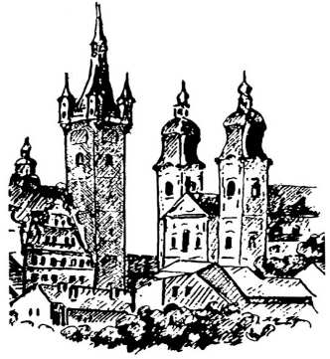
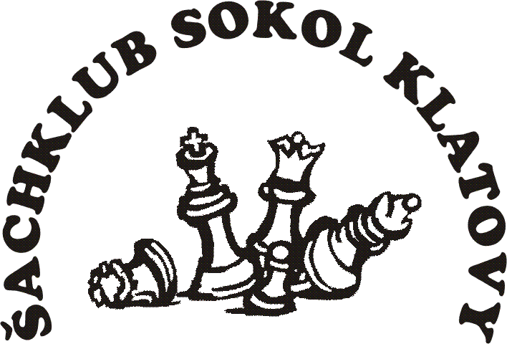
Šachklub Sokol Klatovy

holds

32nd annual chess tournament

OPEN Klatovy 2026

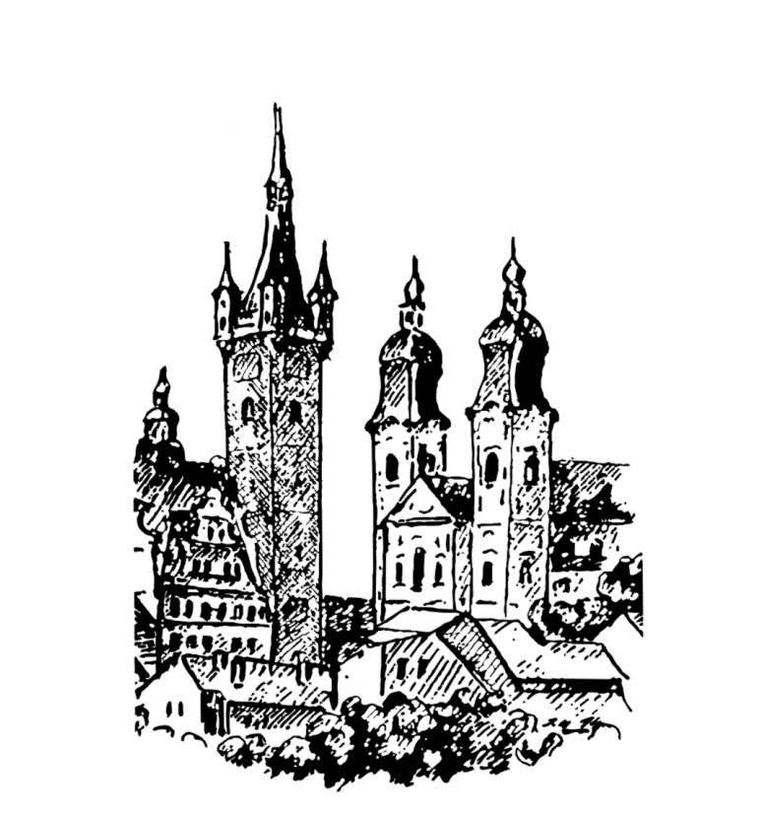
- FIDE OPEN A (ELO > 1800)

- FIDE OPEN B (ELO <2000)

- FIDE OPEN C (Seniors 50+)
this tournament is played as a memorial to Ing. Jaromír Novák
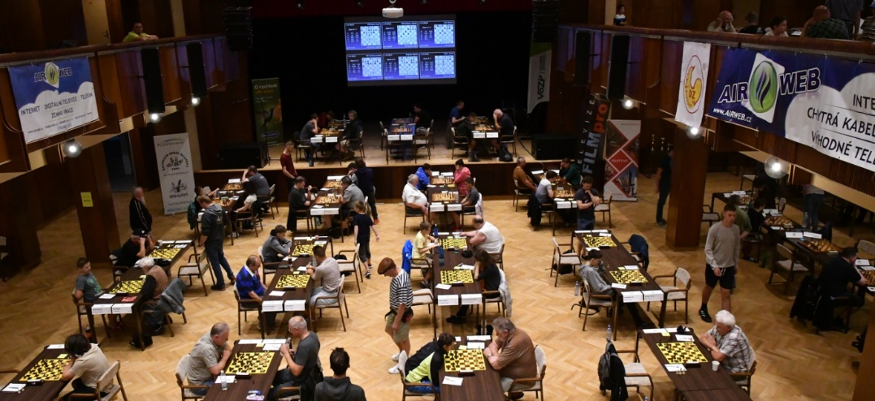

Klatovy, June 27th – July 5th 2026
www.openklatovy.cz


Date: June 27th – July 5th 2026
Venue: The Culture House Klatovy, Domažlická 767, 339 01 Klatovy
Registration: On June 26th from 5 p.m. to 9 p.m., on June 27th from 10 a.m. to 3 p.m.
System of play: Swiss open tournament, 9 rounds, 2 x 2 h + 30 s per move
Accommodation: See below
Catering: The meals will be provided at the venue. It is possible to order lunches and dinners in advance. The menu will be published on the tournament website.
Applications: To be sent by June 7th 2026 to the address of the tournament director.
Director: Ing. Pavel Hrdlica, sachklub.klatovy@seznam.cz, Masarykova 334, 33901 Klatovy, bank account: IBAN CZ50 2010 0000 0021 0250 1446
Organizer: Ing. Karel Nováček, novacek.chess@seznam.cz, phone: +420 737 337 955

Time schedule: 1st round: June 27 at 4 p.m. 4th round: June 30 at 4 p.m. 7th round: July 3 at 2 p.m.
2nd round: June 28 at 4 p.m. 5th round: July 1 at 4 p.m. 8th round: July 4 at 4 p.m.
3rd round: June 29 at 4 p.m. 6th round: July 2 at 4 p.m. 9th round: July 5 at 9 a.m.
Financial prizes: Tournament A Tournament B Tournament C

1st place: 15,000 CZK 4,000 CZK 4,000 CZK
2nd place: 10,000 CZK 3,000 CZK 3,000 CZK
3rd place: 7,000 CZK 2,000 CZK 2,000 CZK
4th place: 5,000 CZK 1,700 CZK 1,700 CZK
5th place: 4,000 CZK 1,500 CZK 1,500 CZK
6th place: 3,000 CZK 1,300 CZK 1,300 CZK
7th place: 2,400 CZK 1,200 CZK 1,200 CZK
8th place: 1,800 CZK 1,100 CZK 1,100 CZK
9th place: 1,600 CZK 1,000 CZK 1,000 CZK
10th place: 1,400 CZK 900 CZK 900 CZK
11th place: 1,200 CZK 800 CZK 800 CZK
12th place: 1,000 CZK 700 CZK 700 CZK

1st woman: 1,000 CZK 700 CZK 700 CZK
2nd woman: 700 CZK 500 CZK 500 CZK
3rd woman: 500 CZK 300 CZK 300 CZK

Team competition prizers: 4-player team tournament wins 2 000,- CZK at tournament A 4-player team tournament wins 1 000,- CZK at tournament B

Material prizes: The best boys and girls in categories U8, U10, U12, U14, U16 in both categories will be given material prizes. The youngest and the oldest participant will receive a material prize as well.
Entry fee: Tournament A Tournament B Tournament C (50+)
(ELO FIDE) (ELO FIDE or CR) (no ELO restrictions)

2300 and more 0 € 0-2000 : 32 € born 1976 and older: 32 € 2200 – 2299 28 €
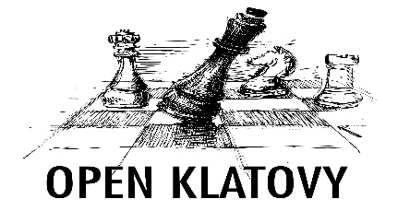
2000 – 2199 36 €
1800 – 1999 44 €

Discounts on entry fee (more discounts can be applied at once):
A. Youth under 16 (born in 2010 and later) – 4 € discount.
B. Women - 4 € discount.
C. Last year’s participants – 4 € discount.
D. Seniors (born in 1961 and earlier) – 4 € discount.
Accompanying program:

• Active chess tournament: (Sunday June 28th at 9:00)
Swiss tournament 7 rounds, 2x15 min., financial prize (800 CZK) and material prizes, entry fee 4 EUR

• Active chess seniors tournament: (Sunday June 28th at 9:00)
Swiss tournament 7 rounds, 2x15 min., for players born in 1961 and earlier, financial prize (800 CZK) and material prizes, entry fee 4 EUR.

• Active chess juniors tournament: (Sunday June 28th at 9:00)
Swiss tournament 7 rounds, 2x15 min., for players born in 2009 and later, category boys born in 2012 and later, category girls born in 2012 and later, material prizes for everyone, entry fee 4 EUR.

• Table tennis tournament: (Monday June 29th at 9:00)
System based on the number of participants, material prizes, starting fee 2 EUR

• Beach volleyball: (Tuesday 30th at 9:00)
Weather permitting. Game format will be determined by the number of participants. Entry fee 6 EUR per team, prizes available.

• Football tournament: (Wednesday July 1st at 9:00)
System based on the number of participants, material prizes, entry fee 12 EUR/team.

• Blitz tournament: (Friday July 3rd at 20:00)
Swiss tournament 15 rounds, 2 x 3 min.+ 2 s, financial prize (800 CZK), material prizes, entry fee 4 EUR

• Tour of town Klatovy
Guided tour of the historical part of the town in Czech. Date to be announced.

Additional information:
Filled-in applications (form is available on tournament website) should be sent via e-mail: sachklub.klatovy@seznam.cz. You can verify your acceptance to the tournament by contacting the tournament director. In the application form state your FIDE ID number, your address, phone number and e-mail. Accepted players who properly cancel their application will get their money for accommodation and starting fee. The cancellation fee is free 14 days before tournament, 8 EUR 7-13 days before the tournament and 12 EUR 1-6 days before the tournament.
The starting fee and accommodation prices should be sent by a bank transfer to the account of tournament’s director: IBAN CZ50 2010 0000 0021 0250 1446. It is possible to send money for more players in one transfer (state the details in the message for recipient or in the e-mail. Accommodation requirements will be dealt with in the order of application arrival for players who already paid starting fee and accommodation price. It is possible to book accommodation from Friday.
All played games will be available for download the day after on the organizer website. Part of the games will be transmitted online. During the registration, there will be an information bulletin available, where you can find information about the accompanying program, interesting facts and participant benefits.
The final ranking will be determined according to the players‘: 1.Points, 2. Buchholz Cut 1, 3.Buchholz, 4.Sonnenborn, 5.Lot. Tournaments A, B and C will be sent for calculation of FIDE ELO and Czech ELO.
During the final ceremony two randomly selected players will receive valuable prizes.


Accomodation |  |  | Price per person and night (€)
Code | Accomodation | Note + distance from venue | 1B | 2B | 3B | 4B | WWW
A | SPŠ boarding school hostel | Newly renovated 2+2 rooms with bathroom. Less than 7 nights (+150 CZK), Voříškova Street 823, limited number of single rooms available. 250 m | 24 | 18 | - | -
B | Hotel Beránek  - category 1 | Toilet, shower and TV in room, 500 m, | 26 | 24 | 24 | - | https://www.beranekklatovy.cz/hotelberanek/
C | Guesthouse  U Parku | Family guesthouse with great Czech cuisine, 700 m, | 26 | 20 | 20 | 20 | https://www.penzion-klatovy.cz/index_en.html
D | Guesthouse  Na Zemědělce | Accommodation in quiet part of Klatovy, 1,3 km, | 26 | 22 | - | - | https://www.sszp.kt.cz/index.php?page=212&lang=cz&r=200
E | Guesthouse  Na Vršku | Family guesthouse, Accommodation in quiet part of Klatovy 1,3 km, | 24 | 18 | 16 | 16
F | Guesthouse  Strnad | Comfortable accommodation next to the venue, 50 m, | 32 | 24 | 20 | - | penzionustrnada,cz/ubytovani-klatovy
G | Geusthouse Kotva | Comfortable accommodation in a newly opened guesthouse in the city center. 300 m | 38 | 30 | 28 | - | Ubytování v penzionu, pivnice | Penzion Kotva Klatovy
H | Guesthouse Na Úhlavě | Basic accommodation on the outskirts of town in beautiful natural surroundings with a garden and fire pit. 2.3 km | 20 | 16 | 16 | 16
I | Hotel  Centrál | Prices include breakfast and wellness, 500 m, | 50 | 46 | - | - | https://www.centralkt.cz/en/uvod.html

Booking the accommodation should be undertaken via the application form. The organizers will notify and contact the accommodation and arrange your booking. We recommend getting information about accommodation availability as soon as possible.
Prices include VAT and city tax. Breakfast is not included. The exception is hotel Centrál which includes breakfast and wellness. It is possible to buy breakfast in some places.
If you need any advice regarding accommodation selection, please contact the organizer.
The accommodation capacity in the places is very limited due to the attractiveness of the date (folklore festival, holidays). Do not hesitate with the accommodation selection.

More about tournament:
www.openklatovy.cz

